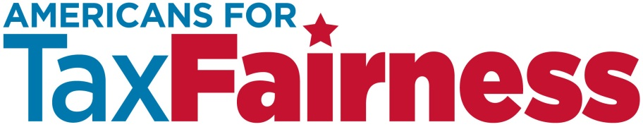

**TALKING POINTS ON THE** [**RYAN TAX PLAN**](http://abetterway.speaker.gov/_assets/pdf/ABetterWay-Tax-PolicyPaper.pdf) **(As of 6/24/16)**

* **Paul Ryan’s tax plan looks a lot like Donald Trump’s tax plan.**
* **Just like the Trump tax plan, the Ryan tax plan overwhelmingly benefits the wealthy.**
* Like Trump, Ryan’s plan will slash the top tax rate paid by the richest 1 percent, giving them huge tax cuts and making inequality in America so much worse.
* The rich don’t need to pay less in taxes. They need to pay their fair share.
* **Just like the Trump tax plan, the Ryan tax plan overwhelmingly benefits big corporations—many of which pay little or no taxes already.**
* Ryan’s tax plan will cut the corporate tax rate nearly in half—dropping it from 35% to 20%.
* Big corporations don’t need to pay less in taxes. They need to pay their fair share.
* Like Trump, Ryan’s tax plan will give a huge tax holiday to corporations that have $2.4 trillion in untaxed profits stashed offshore. The Ryan-Trump plan will let them pay a fraction of what they owe.
* We need to end tax breaks for corporations that ship jobs and profits offshore—not give them even bigger tax breaks, as Ryan and Trump propose to do.

* **The American people do not support more tax breaks for the wealthy and corporations.** According to a recent [Gallup poll (April 6-10, 2016](http://www.gallup.com/file/poll/190802/Taxes_II_160415.pdf)):
* 61% think upper-income people pay too little in taxes; 15% say they pay too much.
* 67% think corporations pay too little; just 12% say they pay too much.
* **It’s time to end the charade that tax cuts don’t cost anything.** Tax giveaways mean we will lose trillions of dollars needed to maintain existing critical services and to pay for new investments. The Ryan-Trump tax giveaways will likely not be paid for by closing other tax loopholes benefitting the rich and corporations. If they are paid for at all, it is likely to be through massive cuts to benefits and services that all of us depend on.
* **Real tax reform should go in the opposite direction, closing tax loopholes and raising revenue to invest in America.**
* A strong and prosperous society is built on the foundations that are paid for with taxes. It takes tax revenue to make our classrooms less crowded, improve roads and bridges, find new medical cures, make sure our communities and country are safe.
* Our tax system should create a level playing field for small businesses that create jobs in America, and ensure that Wall Street plays by the same rules as Main Street. It should not encourage multinationals corporations to move jobs and profits offshore.